Add cover Add comment

**Growing Small Accounts**

1. what you need to avoid
   1. Do not try to rush to make massive gains either pips or % returns
   2. Do not open yourself to large risk in hopes of equally large returns or profits
   3. Do not assume taking small risk trades will not grow your account
   4. Do not sacrifice trading equity for poor planning or lack thereof
2. What you need to aim for
   1. Determine how to realistically anticipate a favorable reward to risk model
   2. Learn to respect the risk side of the trade setups more over the reward
   3. Identify trade setups that permit three reward multiples to one risk or higher
   4. Frame good reward to risk setups that have little impact if unprofitable

The Reality Of Reward To Risk Ratios

**What Will You Need To See In Performance For Profitability?**

|  |  |
| --- | --- |
| **Win Rate** | **Minimum Ratio** |
| 75% | 0.3: 1 |
| 60% | 0.7: 1 |
| 50% | 1 : 1 |
| **40%** | 1.5: 1 |
| **33%** | 2: 1 |
| 25% | 3: 1 |



You need time to let compound interest do its magic

It doesnt take many trades to make 50% in a month but it does take highly selective trades

Pay the most attention to the drawdown, thats the most important. We want to avoid drawdown. Focus on 6% of your equity per month

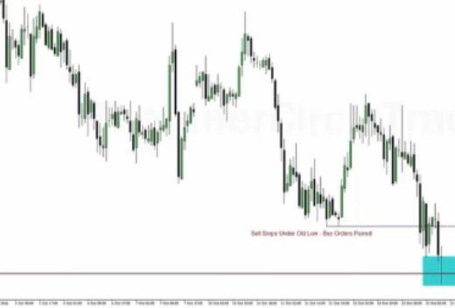

Where Do 6% Per Month Setups Form?

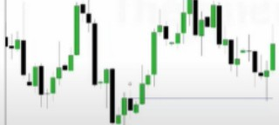r Doily Charts Make It Easy!

Locate a Institutional Orderblock like the one highlighted in the chart to the left.

""'

r-

,""

r "" I"-" 1-

**0-,YBulllt!Orderblodl**

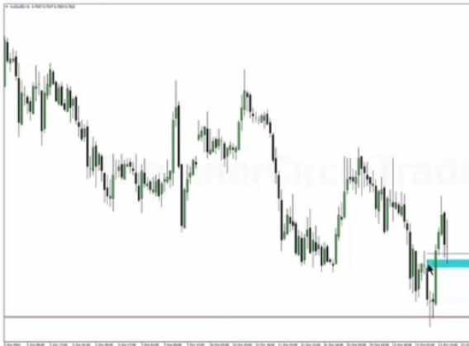

l

I

Know where to take profits before youre getting in Banks trade off of daily levels

Arjo I Twitter, lnstagram I Linktree

Linktree. Make your link do more. https://t.co/HhmmTN1fUI

JavaScript is not available.

*"'!I* https://twitter.com/arjoio